**Supplemental figures and tables**



**Figure S1.** Maximum Clade Credibility tree from BEAST phylogenetic reconstruction. Node labels are posterior probabilities for each clade.

Figures S2-S4 show the UV spectra (210-400 nm) and mass spectra (MS, 100-900 AMU) of unknown PPGs 2, 3, and 5 from the foliageof various *Mimulus* species.

**Figure S2a.** Unknown 2 UV spectra

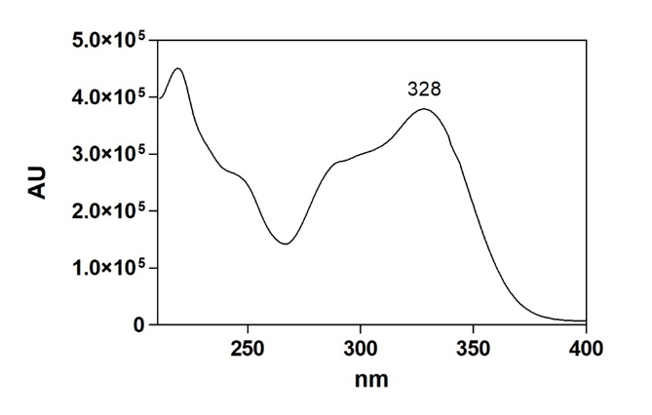

**Figure S2b.** Unknown 2 mass spectra. The molecular weight corresponds to known PPGs β-hydroxyverbascoside and plantomajoside, However, neither have been previously reported in *Mimulus*.

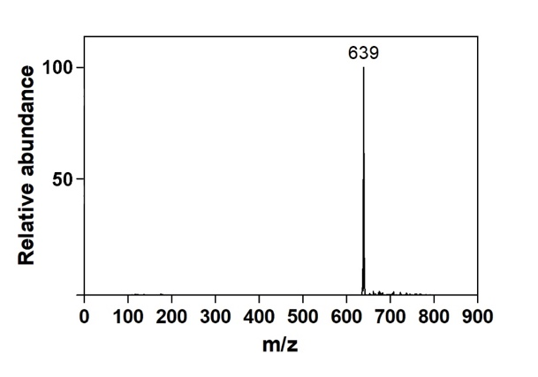

**Figure S3a.** Unknown 3 UV spectra

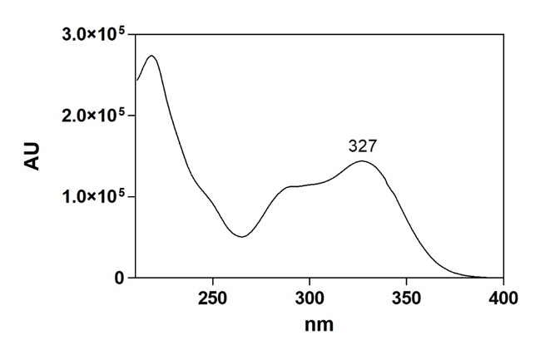

**Figure S3b.** Unknown 3 mass spectra

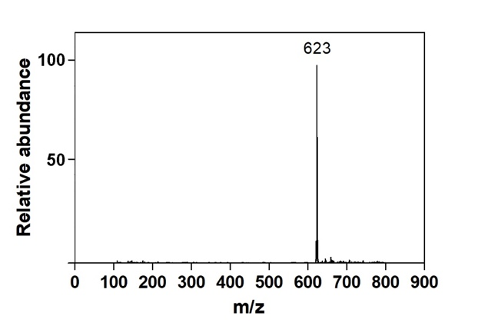

**Figure S4a.** Unknown 5 UV spectra

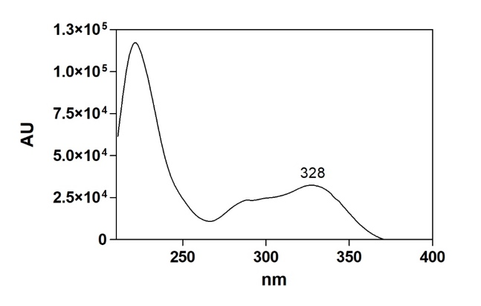

**Figure S4b.** Unknown 5 mass spectra

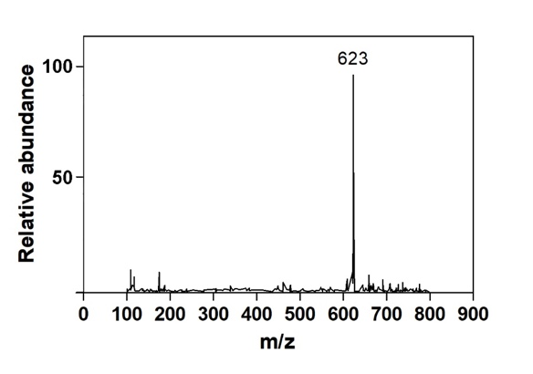

|  |  |  |  |  |  |  |  |  |  |  |  |  |  |  |  |  |  |  |
| --- | --- | --- | --- | --- | --- | --- | --- | --- | --- | --- | --- | --- | --- | --- | --- | --- | --- | --- |
| Species | Sect. | LH | N | CalcA | CalcB | Verb | Conand | Mim | Unkn1 | Unkn2 | Unkn3 | Unkn4 | Unkn5 | Unkn6 | Unkn7 | Total PPGs | NMDS1 | NMDS2 |
| *M. angustatus* | O | A | 2 | 0.00 | 15.85 | 4.09 | 0.00 | 0.00 | 0.00 | 0.00 | 0.00 | 7.35 | 0.00 | 0.00 | 0.13 | 27.42 | -0.35 | -1.05 |
|  |  |  |  | 0.00 | 1.83 | 0.97 | 0.00 | 0.00 | 0.00 | 0.00 | 0.00 | 5.38 | 0.00 | 0.00 | <0.01 | 4.51 |  |  |
| *M. aridus* | D | P | 2 | 0.00 | 0.00 | 30.90 | 0.00 | 0.00 | 0.00 | 0.00 | 0.79 | 0.00 | 0.00 | 0.00 | 0.17 | 31.87 | 0.97 | -0.21 |
|  |  |  |  | 0.00 | 0.00 | 1.24 | 0.00 | 0.00 | 0.00 | 0.00 | 0.05 | 0.00 | 0.00 | 0.00 | 0.02 | 1.21 |  |  |
| *M. aurantiacus* | D | P | 4 | 0.00 | 0.00 | 29.34 | 0.00 | 0.00 | 0.00 | 0.00 | 0.62 | 0.00 | 0.00 | 0.00 | 0.31 | 30.26 | 0.91 | -0.23 |
|  |  |  |  | 0.00 | 0.00 | 3.98 | 0.00 | 0.00 | 0.00 | 0.00 | 0.09 | 0.00 | 0.00 | 0.00 | 0.04 | 4.02 |  |  |
| *M. australis* | D | P | 4 | 0.00 | 0.00 | 30.61 | 0.00 | 0.00 | 0.00 | 0.00 | 2.91 | 0.00 | 0.00 | 0.00 | 0.46 | 33.98 | 0.93 | -0.14 |
|  |  |  |  | 0.00 | 0.00 | 3.06 | 0.00 | 0.00 | 0.00 | 0.00 | 0.5 | 0.00 | 0.00 | 0.00 | 0.08 | 3.31 |  |  |
| *M. bicolor* | Ery | A | 6 | 1.63 | 6.37 | 0.00 | 0.00 | 0.00 | 0.00 | 12.38 | 0.00 | 0.00 | 0.00 | 0.00 | 0.00 | 20.37 | -1.38 | -0.47 |
|  |  |  |  | 0.27 | 1.00 | 0.00 | 0.00 | 0.00 | 0.00 | 2.74 | 0.00 | 0.00 | 0.00 | 0.00 | 0.00 | 3.90 |  |  |
| *M. bolanderi* | Eu | A | 6 | 0.00 | 0.00 | 12.89 | 0.00 | 0.00 | 0.00 | 0.00 | 0.42 | 0.00 | 0.00 | 0.00 | 1.60 | 14.91 | 0.75 | -0.35 |
|  |  |  |  | 0.00 | 0.00 | 5.32 | 0.00 | 0.00 | 0.00 | 0.00 | 0.24 | 0.00 | 0.00 | 0.00 | 0.78 | 6.33 |  |  |
| *M. brevipes* | Eu | A | 3 | 0.00 | 0.00 | 5.21 | 0.00 | 0.00 | 0.00 | 0.00 | 0.03 | 0.00 | 0.00 | 0.00 | 0.42 | 5.66 | 0.75 | -0.44 |
|  |  |  |  | 0.00 | 0.00 | 1.32 | 0.00 | 0.00 | 0.00 | 0.00 | 0.03 | 0.00 | 0.00 | 0.00 | 0.05 | 1.35 |  |  |
| *M. cardinalis* | Ery | P | 6 | 14.03 | 0.30 | 1.90 | 0.00 | 0.00 | 0.00 | 3.01 | <0.01 | 0.00 | 0.00 | 0.00 | 0.85 | 20.10 | -0.54 | -0.09 |
|  |  |  |  | 1.00 | 0.06 | 0.15 | 0.00 | 0.00 | 0.00 | 0.31 | <0.01 | 0.00 | 0.00 | 0.00 | 0.12 | 1.45 |  |  |
| *M. clevelandii* | D | P | 2 | 0.00 | 0.00 | 29.68 | 0.00 | 0.00 | 0.00 | 0.00 | 3.04 | 0.00 | 0.00 | 0.00 | 0.73 | 33.45 | 0.91 | -0.15 |
|  |  |  |  | 0.00 | 0.00 | 2.63 | 0.00 | 0.00 | 0.00 | 0.00 | 0.15 | 0.00 | 0.00 | 0.00 | 0.40 | 2.88 |  |  |
| *M. constrictus* | Eu | A | 4 | 0.00 | 0.00 | 9.34 | 0.00 | 0.05 | 0.00 | 0.00 | 0.32 | 0.00 | 0.00 | 0.00 | 0.82 | 10.53 | 0.67 | -0.12 |
|  |  |  |  | 0.00 | 0.00 | 1.60 | 0.00 | 0.03 | 0.00 | 0.00 | 0.05 | 0.00 | 0.00 | 0.00 | 0.09 | 1.53 |  |  |
| *M. cusickii* | Eu | A | 2 | 0.00 | 0.00 | 4.46 | 0.00 | 0.00 | 0.00 | 0.00 | 0.07 | 0.00 | 0.00 | 0.00 | 0.00 | 4.53 | 1.27 | -0.28 |
|  |  |  |  | 0.00 | 0.00 | 0.75 | 0.00 | 0.00 | 0.00 | 0.00 | <0.01 | 0.00 | 0.00 | 0.00 | 0.00 | 0.75 |  |  |
| *M. douglasii* | O | A | 4 | 0.00 | 0.00 | 9.04 | 0.00 | 0.00 | 0.00 | 0.00 | 10.54 | 0.00 | 0.00 | 0.00 | 0.00 | 19.59 | 1.39 | 0.21 |
|  |  |  |  | 0.00 | 0.00 | 0.74 | 0.00 | 0.00 | 0.00 | 0.00 | 1.63 | 0.00 | 0.00 | 0.00 | 0.00 | 1.67 |  |  |
| *M. filicaulis* | Ery | A | 6 | 2.14 | 9.68 | 0.00 | 0.00 | 0.00 | 0.00 | 9.08 | 0.00 | 0.00 | 0.00 | 0.00 | 0.00 | 20.90 | -1.30 | -0.53 |
|  |  |  |  | 0.30 | 0.75 | 0.00 | 0.00 | 0.00 | 0.00 | 0.79 | 0.00 | 0.00 | 0.00 | 0.00 | 0.00 | 1.38 |  |  |
| Species | Sect. | LH | N | CalcA | CalcB | Verb | Conand | Mim | Unkn1 | Unkn2 | Unkn3 | Unkn4 | Unkn5 | Unkn6 | Unkn7 | Total PPGs | NMDS1 | NMDS2 |
| *M. floribundus* | S | A | 6 | 5.10 | 0.18 | 2.98 | 2.01 | 0.24 | 0.46 | 0.00 | 0.05 | 0.00 | 0.00 | 0.25 | 0.86 | 12.14 | -0.25 | 0.55 |
|  |  |  |  | 1.20 | 0.05 | 0.39 | 0.45 | 0.08 | 0.15 | 0.00 | 0.01 | 0.00 | 0.00 | 0.05 | 0.18 | 1.98 |  |  |
| *M. jungermannioides* | S | P | 6 | 11.77 | 0.64 | 11.57 | 5.44 | 0.55 | 0.00 | 0.00 | 0.72 | 0.00 | 0.00 | 0.34 | 0.63 | 31.67 | -0.20 | 0.47 |
|  |  |  |  | 0.67 | 0.10 | 1.33 | 0.61 | 0.06 | 0.00 | 0.00 | 0.07 | 0.00 | 0.00 | 0.05 | 0.09 |  |  |  |
| *M. kelloggii* | O | A | 1 | 0.00 | 0.00 | 6.80 | 0.00 | 0.00 | 0.00 | 0.00 | 2.37 | 0.00 | 0.00 | 0.00 | 0.98 | 10.15 | 0.89 | 0.02 |
|  |  |  |  | - | - | - | - | - | - | - | - | - | - | - | - | - |  |  |
| *M. norrisii* | S | A | 6 | 3.38 | 0.39 | 0.53 | 26.43 | 1.06 | 7.07 | 0.00 | 0.07 | 0.00 | 0.42 | 1.59 | 0.91 | 41.85 | -0.33 | 1.11 |
|  |  |  |  | 0.41 | 0.12 | 0.05 | 5.88 | 0.19 | 0.62 | 0.00 | 0.02 | 0.00 | 0.26 | 0.36 | 0.13 | 7.23 |  |  |
| *M. palmeri* | Ery | A | 2 | 0.00 | 0.00 | 0.00 | 0.00 | 0.00 | 0.00 | 0.28 | 0.00 | 0.00 | 0.00 | 0.00 | 0.00 | 0.28 | -2.32 | -0.09 |
|  |  |  |  | 0.00 | 0.00 | 0.00 | 0.00 | 0.00 | 0.00 | 0.12 | 0.00 | 0.00 | 0.00 | 0.00 | 0.00 | 0.12 |  |  |
| *M. parviflorus* | D | P | 1 | 0.00 | 0.00 | 26.62 | 0.20 | 0.00 | 0.00 | 0.00 | 0.64 | 0.00 | 0.00 | 0.00 | 0.32 | 27.77 | 0.82 | -0.13 |
|  |  |  |  | - | - | - | - | - | - | - | - | - | - | - | - | - |  |  |
| *M. puniceus* | D | P | 1 | 0.00 | 0.00 | 22.19 | 0.00 | 0.00 | 0.00 | 0.00 | 2.62 | 0.00 | 0.00 | 0.00 | 0.25 | 25.06 | 0.96 | -0.11 |
|  |  |  |  | - | - | - | - | - | - | - | - | - | - | - | - | - |  |  |
| *M. washingtonensis* | S | A | 4 | 14.14 | 0.40 | 0.42 | 2.59 | 0.84 | 0.00 | 0.00 | 0.03 | 0.00 | 0.00 | 0.35 | 0.77 | 19.54 | -0.48 | 0.63 |
|  |  |  |  | 1.52 | 0.12 | 0.11 | 0.61 | 0.08 | 0.00 | 0.00 | 0.01 | 0.00 | 0.00 | 0.07 | 0.09 | 1.89 |  |  |

**Table S1.** Species included in the analysis. Includes section, life history, number of individuals assessed per species, and means (above) and 1 SE (below) for each PPG. For Section (“Sect”), D = Diplacus, Eu = Eunanus, Ery = Erythranthe, O = Oenoe, S = Simiolus. For Life History (“LH”), A = annual, P = perennial.

|  |  |  |  |
| --- | --- | --- | --- |
| Species | *trnL* | *ETS* | *ITS* |
| *D. angustatus* | AY575485 | AY575269 | AY575378 |
| *D. aurantiacus* | AY575494 | AY575281 | AY575389 |
| *D. aridus* |  | AY575288 | AY575396 |
| *D. aurantiacus var australis* |  | AY575289 | AY575397 |
| *D. flemingii* (or *D. parviflorus*) | AY575499 | AY575287 | AY575395 |
| *D. aurantiacus var. puniceus* | AY575493 | AY575280 | AY575388 |
| *E. bicolor* |  | AY575298 | AY575409 |
| *D. bolanderi* |  | AY575241 | AY575352 |
| *D. brevipes* | AY575466 | AY575247 | AY575358 |
| *E. cardinalis* |  | AY575303 | AY575414 |
| *D. clevelandii* |  | AY575278 | AY575386 |
| *D. constrictus* | AY575457 | AY575238 | AY575349 |
| *D. cusickii* | AY575476 | AY575257 | AY575368 |
| *D. douglasii* |  | AY575273 | AY575381 |
| *E. filicaulis* | AY575511 | AY575299 |  |
| *E. floribunda* | AY575526 | AY575319 | AY575430 |
| *E. jungermannioides* | AY575522 | AY575315 | AY575426 |
| *D. kelloggii* | AY575488 | AY575274 | AY575382 |
| *E. norrisii* | AY575529 | AY575322 | AY575433 |
| *E. palmeri* | AY575507 | AY575295 | AY575406 |
| *E.washingtonensis* | AY575523 | AY575316 | AY575427 |

**Table S2** Genbank accessions used for phylogenetic analysis

|  |  |  |  |  |  |
| --- | --- | --- | --- | --- | --- |
| Compound | Retention time (min) | *m*/*z* [M-H]- (Da) | UV λmax  (nm)a | Theoretical *m*/*z* [M-H]- (Da) | Molecular formula |
| Unknown PPG 1 | 4.53 | 609 | 218, 327 | 609.1825 | C28H33O15 |
| Unknown PPG 2 | 4.61 | 640b | 220, 328 | nd | nd |
| Calceolarioside A | 4.84 | 478 | 220, 328 | 477.1402 | C23H25O11 |
| Conandroside | 4.87 | 609 | 220, 328 | 609.1825 | C28H33O15 |
| Verbascoside | 4.92 | 623 | 218, 331 | 623.1981 | C29H35O15 |
| Calceolarioside B | 5.01 | 477 | 218, 327 | 477.1402 | C23H25O11 |
| Unknown PPG 3 | 5.11 | 623c | 220, 327 | nd | nd |
| Unknown PPG 4 | 5.19 | 477 | 216, 325 | 477.1402 | C23H25O11 |
| Mimuloside | 5.32 | 623 | 217, 326 | 623.1981 | C29H35O15 |
| Unknown PPG 5 | 5.39 | 623d | 221, 328 | nd | nd |
| Unknown PPG 6 | 5.73 | 637 | 220, 325 | 637.2138 | C30H37O15 |
| Unknown PPG 7 | 5.78 | 651 | 220, 329 | 651.2294 | C31H39O15 |

**Table S3.** Chemical data for identified and unknown phenylpropanoid glycosides (PPGs) from the foliage of various *Mimulus* species. LC retention times and *m*/*z* [M-H]- (measured at 1 Da resolution) from the current study, UV maxima, theoretical *m*/*z* [M-H]-, and molecular formula data from Keefover-Ring (2014) for the compounds in common with the current study.

Unknown PPGs 1, 4, 6, and 7, correspond to unknown PPGs 10, 8, 15, and 16, respectively, from Keefover-Ring *et al.* (2014). aDetermined in Keefover-Ring *et al.* (2014), except for UV data for unknown PPGs 2, 3, and 5, which were measured in the current study (see Figs. S1a, S2a, and S3a). nd = not determined in this study. bSee Fig. S1b. cSee Fig. S2b. dSee Fig. S3b.

|  |  |  |  |  |
| --- | --- | --- | --- | --- |
| Trait | Blomberg's K | p | Pagel's lambda | p |
| NMDS axis 1 | 1.67 | **0.001** | 1.02 | **0.001** |
| NMDS axis 2 | 0.71 | **0.001** | 0.97 | **0.001** |
| total PPGs | 0.28 | 0.081 | 0.63 | 0.175 |
| Calceolarioside A | 0.44 | **0.025** | 0.51 | **0.010** |
| Calceolarioside B | 0.46 | **0.032** | 1.03 | **0.019** |
| Verbascoside | 0.99 | **0.001** | 0.92 | **0.001** |
| Conandroside | 0.16 | 0.561 | 0.19 | 0.402 |
| Mimuloside | 0.33 | 0.108 | 0.69 | **0.001** |
| *Unknown PPG 1* | 0.15 | 0.595 | 0.00 | 1.000 |
| Unknown PPG 2 | 0.50 | **0.037** | 0.85 | **0.006** |
| Unknown PPG 3 | 0.47 | **0.023** | 1.02 | **0.028** |
| *Unknown PPG 4* | 0.69 | **0.045** | 1.03 | **0.001** |
| *Unknown PPG 5* | 0.14 | 0.693 | 0.00 | 1.000 |
| Unknown PPG 6 | 0.20 | 0.449 | 0.38 | 0.126 |
| Unknown PPG 7 | 0.34 | **0.028** | 0.00 | 1.000 |

**Table S4**. Assessment of phylogenetic signal for all surveyed chemical defenses. Italics indicate that there were three or fewer taxa that produced a particular phenylpropanoid glycoside. Caution is needed in interpreting and comparing phylogenetic signals between the individual PPGs found only in a few taxa as they do not behave as continuous variables.

|  |  |  |  |  |  |  |
| --- | --- | --- | --- | --- | --- | --- |
| **Response Phenotype** | **Predictor** | **covariate** | **Value** | **Std.Error** | **t-value** | **p-value** |
| TotalPPGs | bFFP | - | -0.12 | 0.05 | -2.46 | **0.024** |
| TotalPPGs | life history | - | 9.35 | 4.88 | 1.92 | *0.071* |
| TotalPPGs | NFFD | - | 0.14 | 0.03 | 4.13 | **<0.001** |
| TotalPPGs | PAS | - | -0.28 | 0.05 | -5.29 | **<0.001** |
| TotalPPGs | MAT | - | 2.64 | 0.55 | 4.79 | **<0.001** |
| TotalPPGs | Latitude | - | 0.21 | 0.84 | 0.26 | 0.801 |
| TotalPPGs | Elevation | - | -0.01 | <0.01 | -3.30 | **0.004** |
| NMDS1 | bFFP | - | <0.01 | <0.01 | -0.13 | 0.902 |
| NMDS1 | life history | - | 0.42 | 0.17 | 2.47 | **0.023** |
| NMDS1 | NFFD | - | <0.01 | <0.01 | 0.22 | 0.827 |
| NMDS1 | PAS | - | <0.01 | <0.01 | 0.23 | 0.821 |
| NMDS1 | MAT | - | 0.01 | 0.03 | 0.23 | 0.817 |
| NMDS1 | Latitude | - | 0.04 | 0.03 | 1.39 | 0.182 |
| NMDS1 | Elevation | - | <0.01 | <0.01 | -1.61 | 0.124 |
| NMDS2 | bFFP | - | <0.01 | <0.01 | -1.45 | 0.164 |
| NMDS2 | life history | - | -0.01 | 0.13 | -0.11 | 0.913 |
| NMDS2 | NFFD | - | <0.01 | <0.01 | 1.13 | 0.271 |
| NMDS2 | PAS | - | <0.01 | <0.01 | -1.64 | 0.117 |
| NMDS2 | MAT | - | 0.03 | 0.02 | 1.67 | 0.112 |
| NMDS2 | Latitude | - | -0.01 | 0.02 | -0.28 | 0.783 |
| NMDS2 | Elevation | - | <0.01 | <0.01 | -1.29 | 0.212 |
| TotalPPGs | Latitude | Elevation | -0.62 | 0.72 | -0.86 | 0.402 |
| NMDS1 | Latitude | Elevation | 0.03 | 0.03 | 0.91 | 0.376 |
| NMDS2 | Latitude | Elevation | -0.02 | 0.02 | -0.77 | 0.450 |

**Table S5.** Phylogenetic generalized least squared (PGLS) model results. bFFP is beginning of the frost free period (Julian days), NFFP is the number of frost free days, PAS is precipitation as snow (August-July, mm), and MAT is mean annual temperature. Climate data comes from 1981-2010 climate normals downloaded from ClimateNA. P-values in bold are those significant at α = 0.05.